**K-MEANS CLUSTERING**

K in K-Means = No. of clusters that you want to create.

Example:

This is the data given, and this is how it looks when we plot it on a line.

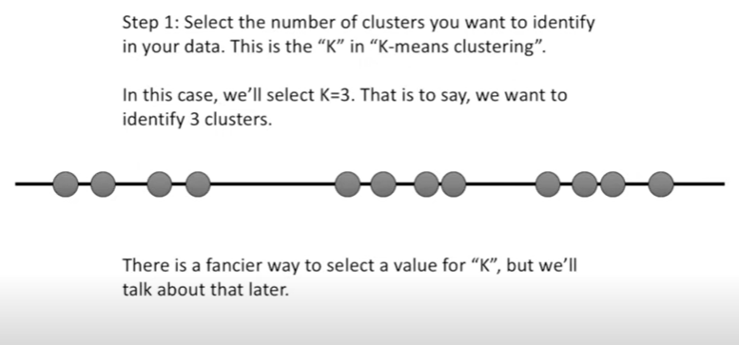

Step 1. Select the value of K , say 3 here. There is another way to identify K , later on.

Step 2.